Design No:
Class: ?
Sheet No: 1/4

NAME & ADDRESS OF APPLICANT(s):
National University of Sciences and Technology (NUST),
Residing at School of / College of ________________, Sector H-12, Islamabad, Pakistan.

REPRESENTATION WILL APPEAR HERE
• THE SIZE OF THE REPRESENTATION SHALL NOT BE LESS SIZE THAN 5 BY 4 INCHES
• STAPLES MUST NOT BE USED
• AT LEAST 1/4” SHOULD BE LEFT AROUND
• REPRESENTATION MUST APPEAR ON ONESIDE OF THE PAPER
• VIEWS MUST BE EXECUTED IN AN UPRIGHT POSITION ON THE SHEET
• At least 4 representations / figures from different angels are to be submitted with same pattern on different sheets

Figure 1: Perspective View (other captions can be selected from list of captions of title of design

NOVELTY STATEMENT: The novelty resides in the shape or configuration of the article “title of design” as shown in the accompanying representation. (Anyone novelty statement can be chosen based upon the novelty or originality of the new features of the design applied to an article from the list of novelty statements provided separately)
DISCLAIMER: No claim is made by virtue of this registration to any right to the exclusive use of the words, letters, numerals etc appearing in the design.
No claim is made by virtue of this registration in respect of any mechanical or other action of the mechanism whatever or I respect of any mode or principle of construction of the article.
No claim is made by virtue of this registration to any right to the use as a Trade Mark of what is shown in the representations.

National University of Sciences and Technology (NUST)
Design No:
Class: ?
Sheet No: 2/4

NAME & ADDRESS OF APPLICANT:
National University of Sciences and Technology (NUST),
Residing at School of / College of ________________, Sector H-12, Islamabad, Pakistan.
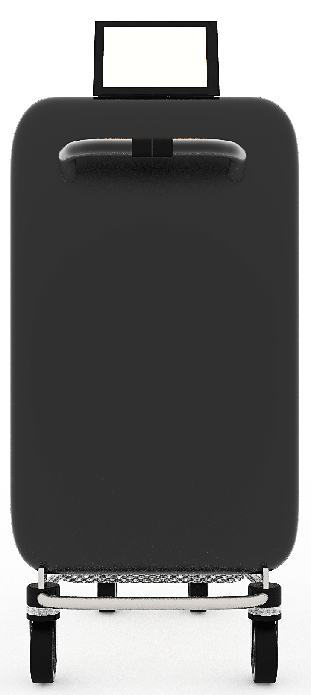

NOVELTY STATEMENT: The Novelty resides in the shape and configuration pattern of the design “River and ocean cleanup device” as illustrated in the above photographs encircled with red ink.
DISCLAIMER: No claim is made by virtue of this registration to any right to the exclusive use of the words, letters, numerals etc appearing in the design. No claim is made by virtue of this registration in respect of any mechanical or other action of the mechanism whatever or I respect of any mode or principle of construction of the article.
No claim is made by virtue of this registration to any right to the use as a Trade Mark of what is shown in the representations

Figure 2: Front View (other captions can be selected from list of captions of title of design

NOVELTY STATEMENT: The novelty resides in the shape or configuration of the article “title of design” as shown in the accompanying representation. (Anyone novelty statement can be chosen based upon the novelty or originality of the new features of the design applied to an article from the list of novelty statements provided separately)
DISCLAIMER: No claim is made by virtue of this registration to any right to the exclusive use of the words, letters, numerals etc appearing in the design.
No claim is made by virtue of this registration in respect of any mechanical or other action of the mechanism whatever or I respect of any mode or principle of construction of the article.
No claim is made by virtue of this registration to any right to the use as a Trade Mark of what is shown in the representations.

National University of Sciences and Technology (NUST)
Design No:
Class: ?
Sheet No: 3/4
NAME & ADDRESS OF APPLICANT:
National University of Sciences and Technology (NUST),
Residing at School of / College of ________________, Sector H-12, Islamabad, Pakistan.
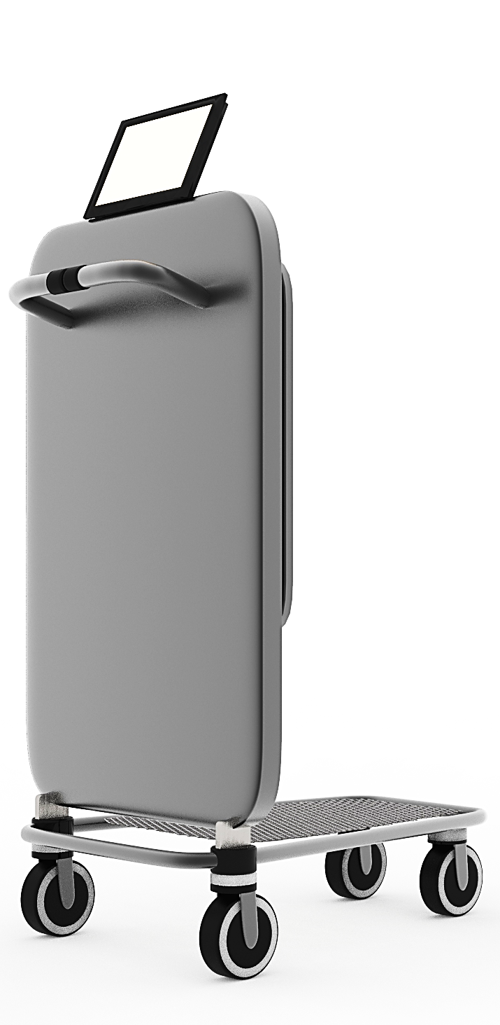

Figure 3: Isometric View (other captions can be selected from list of captions of title of design

NOVELTY STATEMENT: The novelty resides in the shape or configuration of the article “title of design” as shown in the accompanying representation. (Anyone novelty statement can be chosen based upon the novelty or originality of the new features of the design applied to an article from the list of novelty statements provided separately)
DISCLAIMER: No claim is made by virtue of this registration to any right to the exclusive use of the words, letters, numerals etc appearing in the design.
No claim is made by virtue of this registration in respect of any mechanical or other action of the mechanism whatever or I respect of any mode or principle of construction of the article.
No claim is made by virtue of this registration to any right to the use as a Trade Mark of what is shown in the representations.

National University of Sciences and Technology (NUST)
Design No:
Class: ?
Sheet No: 4/4
NAME & ADDRESS OF APPLICANT:
National University of Sciences and Technology (NUST),
Residing at School of / College of ________________, Sector H-12, Islamabad, Pakistan.
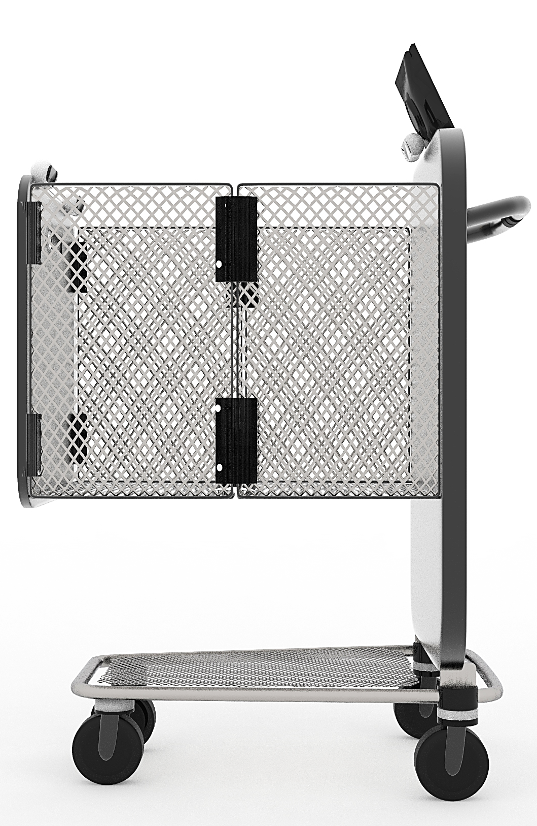

Figure 4: Side View (other captions can be selected from list of captions of title of design

NOVELTY STATEMENT: The novelty resides in the shape or configuration of the article “title of design” as shown in the accompanying representation. (Anyone novelty statement can be chosen based upon the novelty or originality of the new features of the design applied to an article from the list of novelty statements provided separately).
DISCLAIMER: No claim is made by virtue of this registration to any right to the exclusive use of the words, letters, numerals etc appearing in the design.
No claim is made by virtue of this registration in respect of any mechanical or other action of the mechanism whatever or I respect of any mode or principle of construction of the article.
No claim is made by virtue of this registration to any right to the use as a Trade Mark of what is shown in the representations.

National University of Sciences and Technology (NUST)

